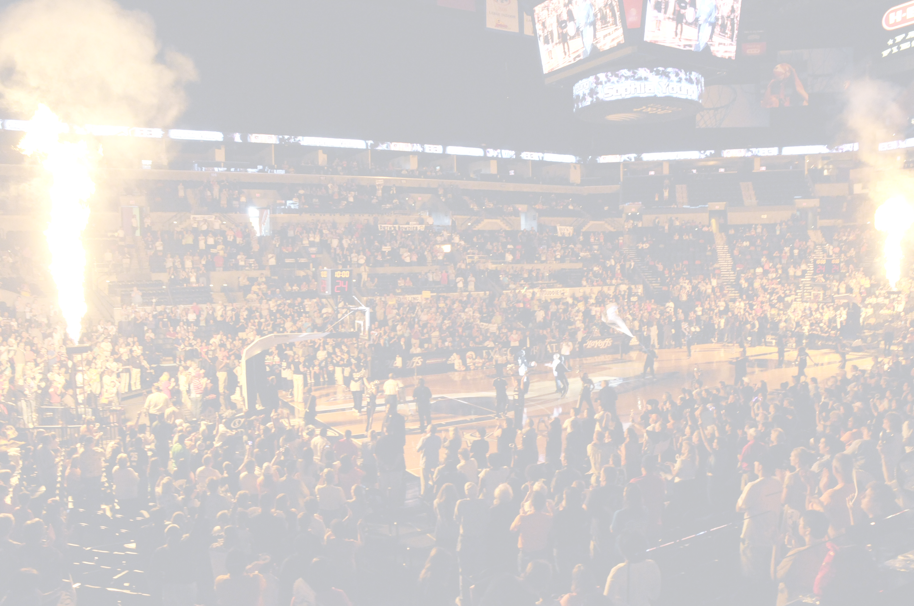

WHAT THE PACKAGE WILL INCLUDE:

- INVITE TO AN INFLUENCER EVENT IN HOUSTON ON JUNE 9TH
- FREE PARKING FOR ALL 6 GAMES
- VISIT FROM A SILVER STARS PLAYER DURING THE LAST GAME OF THE SEASON.
- 15% DISCOUNT FOR THOSE SPECIFIC WEEKENDS AT THE GRAND HYATT LOCATED IN DOWNTOWN SAN ANTONIO.



Games Included in Package

Game 1 Sat., June 13 ($1 Night) New York Liberty
Game 2 Sat., August 15 Phoenix Mercury
Game 3 Fri., August 21 ($1 Night) Los Angeles Sparks
Game 4 Sat., August 29 Detroit Shock
Game 5 Sat., September 5 Los Angeles Sparks
Game 6 Sat., September 12 ($1 Night) Seattle Storm

$1 Night = Hot Dogs, Soft Drinks, and Draft Beer

Houston Pack Prices


Level | C | D | E | F
6-Pack Price | $272.10 | $188.10 | $128.10 | $56.10
6-Pack Price/Ticket | $45.35 | $31.35 | $21.35 | $9.35
Gate Price/Ticket | $50.35 | $33.35 | $22.35 | $10.35


Name: _____________________________________________________
Address: ___________________________________________________
City: ______________________________ST: ______Zip:____________
Daytime #: _____________________Evening #: ___________________
Email:_______________________________________________
Select Method of Payment:
VISA MC DISC AMEX Cash/MO Check #: _________
Credit Card # _______________________________
3-digit security code:_________ Exp. Date: __________

Signature: __________________________________________________
Price:__________ X # of seats______= $_________

*Purchases are Non-Refundable

Please make checks payable to:
San Antonio Silver Stars

Mailing Address: San Antonio Silver Stars
Attn: Alma Lara
One AT&T Center
San Antonio, TX 78219

*By purchasing a ticket, you agree that Spurs Sports & Entertainment and their partners may contact you regarding team news and special offers.

